Cau 1:
- Use case diagram
Use case search movie information
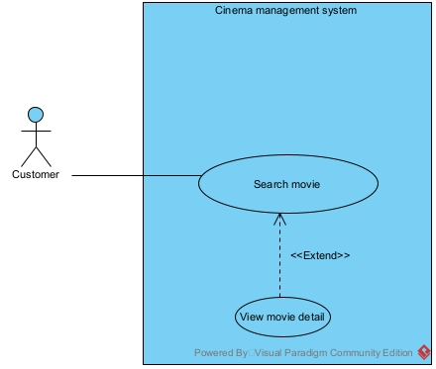
Search movie: this use case enable the customer to enter movie name and search for movie
View movie detail: this use case enable the customer to view detail information about a movie

Use case schedule showtime
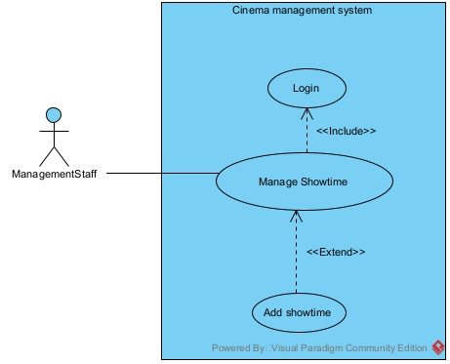
Login: this use case enable the Management Staff to log into the system
Manage showtime: this use case enable the managament staff to add, delete or change showtime
Add showtime: this use case enable the management staff to add a new showtime

- Scenario
Use case search movie information
Use case | Search movie information
Actor | Customer
Pre-condition | At least 1 movie is saved in the system
Post-condition | Customer can see the movie detail
Main events | - Customer enter the system  - The system display the main customer menu  - Customer click the search movie button  - The system display the search movie interface  - The customer enter the movie name and click search  - The interface display a list of movie with related name  - The customer click on a movie  - The system display the interface with the movie detail, such as year, director, description
Exception | 6. The system display an empty list  6.1 the customer re-enter the movie name correctly and click search  6.2 the interface display the list as in step 6
Use case schedule showtime
Use case | Schedule showtime
Actor | Management staff
Pre-condition | Management staff has an account
Post-condition | The new showtime is saved in the database
Main events | - Management staff enter the system  - The system display the login interface  - Management staff enter username, password and click login  - The system display the main staff menu interface  - The management staff click the add more showtime button  - The system display the add show time interface with a choose movie button, choose timeslot and room dropdown  - The management staff choose the timeslot and date, then choose avaiable room from the dropdown menu, and click choose movie  - A search interface appear to search movie  - The management staff enter movie name and click search  - The interface display a list of movie with related name  - The management staff click on a movie  - The system display the add showtime interface with the movie added  - The management staff click save  - The system display a success message
Exception | 4. the system display login error message  4.1 the management staff click ok  4.2 the system display the login interface  4.3 the management staff re-enter username and password correctly and click login  4.4 the system display the interface in step 4  10. The system display an empty list  10.1 the customer re-enter the movie name correctly and click search  10.2 the interface display the list as in step 6

Cau 2:
- Extract entity class
Step 1: Describe the system in a paragraph
The system is a cinema management system could be used by user such as management staff, saler and customers. The management staff can view the types of statistics: movies, customers, seat and room. Management staff can also schedule showtimes, manage movie and theater information (add, edit, delete). The saler can sell tickets at the counter to customers, issuing membership cards to customers. Customer can register for membership, search, buy tickets online, buy tickets at the counter.
Step 2: Extract noun
- Related to people: user, management staff, saler, customer
- Related to things: movie, theater, room, seat, membership card, ticket, counter, showtime
- Related to the system: statistics
Step 3: Evalute noun
- User: create class User: name, username, password, email, phone, address
- Management staff: create class ManagementStaff
- Saler: create class Saler
- Customer: create class Customer
- Movie: create class Movie: name, year, rating, description, director
- Theater: create class Theater: name, address, phone
- Room: create class Room: name, condition, screenType
- Seat: create class Seat: name, type
- Membership card: create class MembershipCard: dateCreate, type, dateExpire
- Ticket: create class Ticket: price, status
- Counter: out of scope
- Showtime: create class Showtime: timeStart, timeEnd, date
- Statistics: create class MovieStatistics, CusomterStatistics
Step 4: determined quantity relationship between object
- 1 customer has 1 MembershipCard, and 1 MembershipCard belong to 1 Customer -> 1-1 relationship
- 1 Ticket has 1 Customer, 1 Customer can have many Ticket -> 1-n relationship
- 1 Ticket has 1 Saler, 1 Saler can have many Ticket -> 1-n relationship
- 1 ManagementStaff can create many Showtime, 1 Showtime can be create by 1 ManagementStaff -> 1-n relationship
- 1 Theater has many Room, a Room must belong to 1 Theater -> 1-n relationship
- 1 Room has many Seat, a Seat must belong to 1 Room -> 1-n relationship
- 1 Room has many Showtime, 1 Showtime belong to 1 Room: 1-n relationship
- 1 Movie has many Showtime, 1 Showtime has to 1 Movie: 1-n relationship
- 1 Showtime has many Ticket, 1 Ticket belong to 1 Showtime: 1-n relationship
- 1 Movie has many Ticket, 1 Ticket belong to 1 Movie: 1-n relationship
Step 5: determined the object relationship between object
1 Seat can belong to many Ticket, 1 Ticket can only have 1 Seat -> 1-n relationship
- Inherit(is a):
  - Management staff, Saler, Customer is a User
  - MovieStatistics inherit from Movie
  - CustomerStatistics inherit from customer
- Composition(is part of):
  - A room must belong to a theater
  - A seat must belong to a room
- Aggregation(has a):
  - A showtime has a room, movie and management staff
  - MembershipCard have a Customer
  - A ticket have a Saler, Customer, movie, Showime and Seat

- Build entity class diagram
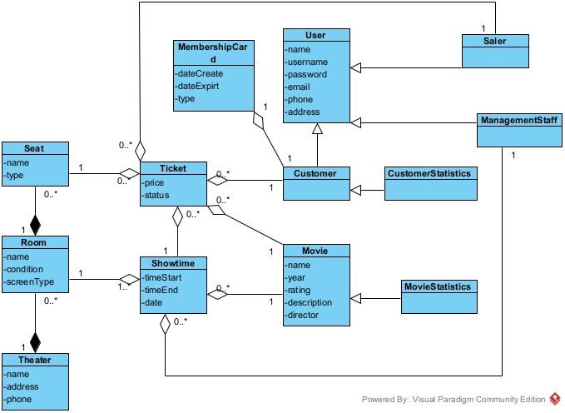
Cau 5:
- Package diagram
The system packages are divided as follow:
- All Model class are placed in the Model package
- All DAO class are placed in the DAO package
- All Controller class are placed in the Controller package
- All jsp class are place in the View Package. The View Package are further divided as follow:
  - All jsp package related to the customer are place in the subpackage Customer
  - All jsp package related to the staff are place in the subpackage Staff
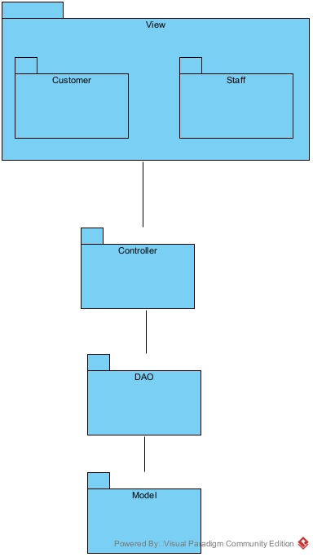
- Deployment diagram
The system are deploy as follow:
- Client: many client send request to the server through web browser(Google Chrome 80+, Microsoft Edge 78+, Mozilla Firefox 80+)
- Server: 1 server handle user request and send queries to the database(JDK 23, Apache Tomcat 10.1.24, MySQL Connector 8.4.0, JDBC 12.6.1)
- Database: 1 databse server store data and handle queries(SQL Server 16.0.1160.1)
- Connection:
  - Client <-> Server: HTTP
  - Server <-> Database: JDBC
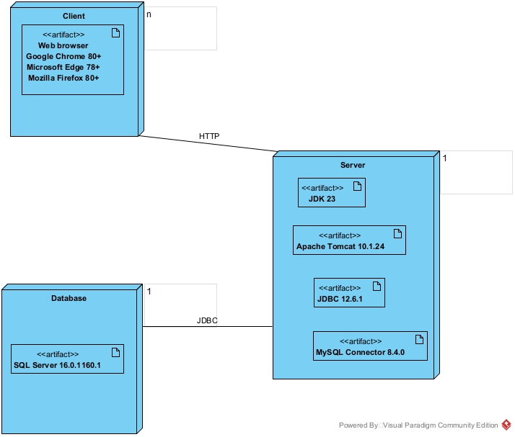
Cau 3:

